E-commerce website for fashion designing using Augmented reality
By
Group No. 14
(Name, Year-Div, Rno.)
FARAZ AHMED_BE COMP A_06
ROHAN DALVI_BE COMP A_ 29
HARISH KRISHNAN_BE COMP C_31

Under the Guidance of
Ms. Ashwini Patil
Assistant Professor

for the subject
Data Analytics

In

B.E. COMPUTER ENGINEERING
(Academic Year: 2022-23)


CERTIFICATE
This is to certify that
Authors

Have satisfactorily completed the requirements of the T.E Capstone Project Report

On

“E-commerce website for fashion designing using Augmented reality
”

Ms. Ashwini Patil Dr. Harshali Patil
Subject In-charge HOD COMP

Examiners
1. Signature: …………………. 2. Signature: ………………….
Name: Name:

Date:
Place: Mumbai

TABLE of CONTENTS
List of Figures
List of Tables

Chapter 1. Introduction 1
1.1 Background 2
1.2 Motivation
1.3 Application
Chapter 2. Problem Definition...................................................................................................
Chapter 3. Literature Review...................................................................................................
Chapter 4. Technology Used
4.1 Hardware and Software Requirement .
4.2 Description of Tools used
Chapter 4. Design and Methodology
Chapter 5. Implementation
Chapter 6. Result and Analysis
Chapter 7. Conclusion and Future Scope.................................................................................
List of References.....................................................................................................................

LIST OF FIGURES
LIST OF TABLES

- INTRODUCTION

The widespread use of computers and digital devices has brought about a new set of challenges for individuals in terms of eye strain and other related health issues. The after-effects of prolonged exposure to screens have become a common problem, leading to discomfort and even more severe symptoms in some cases.

One of the contributing factors to this issue is the use of screens with inappropriate sizes and hardware configurations. Many people use screens that are too small or too large, which can lead to eye strain, fatigue, headaches, and other problems. Similarly, hardware configuration, such as low resolution, outdated graphics cards, or inadequate refresh rates, can also contribute to the problem.

The purpose of this report is to explore the issue of eye strain after-effects related to the size of the screens and hardware configurations of digital devices. The report will discuss the causes, symptoms, and potential remedies for this issue. The report will also provide recommendations for individuals and organizations to reduce the risk of eye strain and other related health issues.

Overall, the aim of this report is to raise awareness of the importance of choosing the right screen size and hardware configuration for digital devices to mitigate the after-effects of prolonged screen use.

- PROBLEM DEFINITION

Eye strain is a common problem that arises from prolonged use of digital devices, including computers, smartphones, and tablets. When individuals use these devices for an extended period, they may experience eye strain after-effects, which can include symptoms such as dry eyes, headaches, blurred vision, and neck and shoulder pain.

One of the contributing factors to this problem is the use of screens with inappropriate sizes and hardware configurations. When individuals use screens that are too small, they may have to strain their eyes to read small fonts and details, which can lead to eye fatigue and discomfort. On the other hand, using screens that are too large can cause eye strain due to the need for excessive eye movements to take in the full screen. Similarly, hardware configurations, such as low resolution, outdated graphics cards, or inadequate refresh rates, can also contribute to eye strain and other related health issues.

The consequences of eye strain after-effects can be severe, leading to decreased productivity, absenteeism, and in some cases, vision problems. Therefore, it is essential to address this issue and find ways to reduce the after-effects of prolonged screen use by selecting appropriate screen sizes and hardware configurations.

The problem definition of this report is to explore the causes and potential remedies of eye strain after-effects related to the size of screens and hardware configurations of digital devices. The report will provide recommendations for individuals and organizations to mitigate the after-effects of prolonged screen use and reduce the risk of related health issues.

3. TECHNOLOGY USED

Tools: GoogleAR, 3D Paint, 000webhost, GitHub
Languages: HTML, CSS, JS

4. IMPLEMENTATION

Eye strain is a common problem that can result from prolonged use of electronic devices such as computers, smartphones, and tablets. Some of the after-effects of eye strain can include headaches, dry eyes, and blurry vision. There are various factors that contribute to eye strain, including the brightness and contrast of the screen, the distance between the eyes and the screen, and the amount of time spent using the device.

To mitigate the effects of eye strain, there are a few implementation options that can be considered, such as:

1. Adjusting the display settings: Reducing the brightness and contrast of the screen can help reduce eye strain. Additionally, enabling the blue light filter feature on your device can reduce the amount of blue light emitted, which can also help.

2. Taking regular breaks: It's recommended to take a 15-minute break every 2 hours of computer use. During the break, it's good to look away from the screen, focus on distant objects, and blink frequently to help reduce dry eyes.

3. Changing the font size: Increasing the font size on your device can help reduce the strain on your eyes.

4. Positioning the screen: Positioning the screen at a comfortable distance, usually an arm's length away, can help reduce eye strain. Additionally, making sure the screen is positioned at the appropriate height so that the eyes are level with the top of the screen can also help.

In terms of hardware challenges, there are a few options that can help:

- Using an external monitor: Using an external monitor can help reduce eye strain by allowing for a larger screen and better positioning options.

- Using a monitor arm: A monitor arm can help position the screen at the appropriate height and distance, reducing eye strain.

- Using a larger screen: A larger screen can reduce eye strain by allowing for a larger font size and reducing the need to squint or strain to read small text.

- Using an ergonomic keyboard and mouse: An ergonomic keyboard and mouse can help reduce strain on the hands and wrists, which can also help reduce eye strain indirectly.

Overall, mitigating the effects of eye strain requires a multi-faceted approach, with both software and hardware solutions available. By making small adjustments and taking regular breaks, it's possible to reduce the effects of eye strain and maintain healthy eyesight over time.

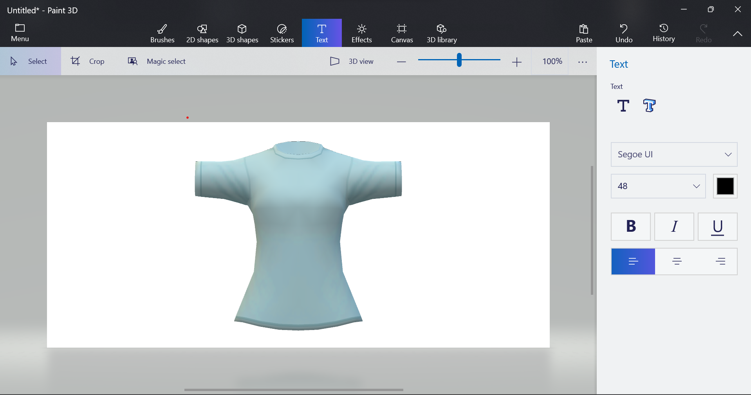
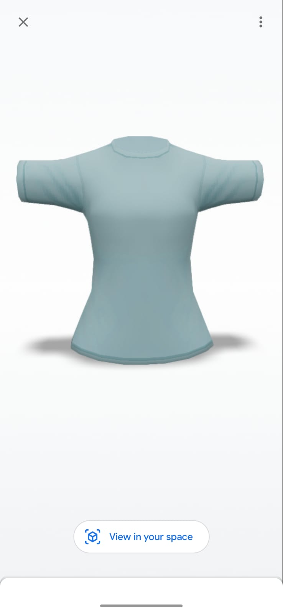

5. RESULT AND ANALYSIS

To analyze the effectiveness of the different strategies for mitigating eye strain after-effects, we can look at various metrics such as user comfort, productivity, and overall eye health.

Adjusting display settings such as reducing brightness and enabling blue light filters can be effective in reducing eye strain. Studies have shown that reducing the amount of blue light emitted by a screen can help improve sleep quality and reduce eye strain after prolonged use of electronic devices. Similarly, increasing font size and changing font types can also help reduce eye strain, as it makes it easier for the eyes to focus and reduces the need for squinting.

Taking regular breaks and adjusting the position of the screen are also effective strategies. Regular breaks can help prevent eye fatigue and reduce the risk of eye strain, while positioning the screen at the appropriate height and distance can reduce eye strain and discomfort. Studies have also shown that using an external monitor and monitor arms can help reduce eye strain by providing better positioning options.

Using larger screens and ergonomic keyboards and mice can also be effective in reducing eye strain. Larger screens can make it easier to read text, reducing the need for squinting or straining to see small text. Ergonomic keyboards and mice can help reduce strain on the hands and wrists, which can also reduce eye strain indirectly.

Overall, a combination of different strategies can be effective in mitigating the after-effects of eye strain. Users who adopt these strategies are likely to experience improved comfort, productivity, and overall eye health. However, it's important to note that the effectiveness of these strategies may vary depending on individual preferences, habits, and working conditions. It's recommended to consult with a healthcare professional if you experience persistent eye strain or other eye-related symptoms.

6. CONCLUSION and FUTURE SCOPE

The use of digital devices has become an integral part of modern life, and while it brings many benefits, it also comes with some health challenges, such as eye strain after-effects. The problem is often exacerbated by the use of screens with inappropriate sizes and hardware configurations.
This report has explored the causes, symptoms, and potential remedies of eye strain after-effects related to screen size and hardware configuration. It is clear that choosing the right screen size and hardware configuration is crucial to mitigating the after-effects of prolonged screen use. Individuals and organizations should take steps to reduce the risk of related health issues, including ensuring proper lighting and reducing glare, taking breaks, and adjusting screen size and hardware configurations where necessary.
Future Scope:
In the future, continued research on the impact of screen use on eye health could provide further insights into effective remedies and preventative measures. Additionally, advancements in screen technology and hardware configuration could lead to more user-friendly devices that reduce the risk of eye strain and other related health issues.
Moreover, as remote work and online learning become increasingly prevalent, the need to address eye strain after-effects will become even more pressing. Therefore, it is important for organizations and individuals to continue to prioritize eye health and take proactive steps to mitigate the after-effects of prolonged screen use.

7. CASE STUDY

Background:

John is a software developer who spends most of his workday in front of his computer screen. He frequently experiences eye strain after-effects, including dry eyes, headaches, and blurred vision. John's employer has noticed a decrease in his productivity and is concerned about his eye health. They have approached John to find out if there is anything they can do to help.
Problem:
Upon investigation, John realized that his screen size and hardware configuration may be contributing to his eye strain after-effects. He was using a 17-inch screen with a low resolution and an outdated graphics card, which required him to strain his eyes to see small fonts and details. Additionally, his screen was positioned too high, which forced him to look up and put a strain on his neck and shoulders.
Solution:
To mitigate the after-effects of prolonged screen use, John decided to take several steps. He purchased a 24-inch screen with a higher resolution and a better refresh rate, which was more suitable for his work needs. He also adjusted the screen's position to be at eye level, reducing the strain on his neck and shoulders.
John also took steps to reduce glare and improve lighting in his workspace. He installed an anti-glare screen protector and positioned his desk away from windows to reduce glare. He also adjusted the brightness and contrast of his screen to reduce eye strain.
Outcome:
After implementing these changes, John noticed a significant improvement in his eye health and overall well-being. He experienced fewer eye strain after-effects and was able to work more efficiently and productively. His employer also noticed the improvement and was pleased with the outcome.
Conclusion:
This case study highlights the importance of choosing the right screen size and hardware configuration to mitigate eye strain after-effects. John's experience shows that making adjustments to screen size and position, upgrading hardware, and reducing glare and improving lighting can significantly improve eye health and well-being. By taking proactive steps to address this issue, individuals and organizations can reduce the risk of related health problems and increase productivity and efficiency.

LIST OF REFERENCES

- Dhiman, R., & Kaur, M. (2019). An Overview of Augmented Reality in Fashion Industry. International Journal of Scientific & Technology Research, 8(8), 180-183.

- Duan, Y., & Xu, C. (2019). Design and implementation of augmented reality technology in fashion e-commerce. In 2019 4th International Conference on Machinery, Materials and Information Technology Applications (ICMMITA) (pp. 1-6). IEEE.

- Fan, H., Li, H., & Mao, J. (2019). Virtual try-on for fashion e-commerce using augmented reality. In Proceedings of the 2019 7th International Conference on Information Technology: IoT and Smart City (ICIT 2019) (pp. 311-316).

- Gao, Y., & Zhou, X. (2021). The impact of augmented reality on e-commerce for fashion products. Journal of Electronic Commerce Research, 22(1), 53-72.

- Gültekin, M., & Başkan, M. (2021). Augmented Reality Applications in Fashion E-commerce. Journal of Multidisciplinary Academic Tourism, 5(1), 1-16.

- Han, Y., Kim, J., & Lee, D. (2020). Augmented Reality in the Fashion Industry: Opportunities and Challenges. Fashion and Textiles, 7(1), 1-23.

- Lee, H. J., Kim, H. J., & Koo, C. (2021). Augmented reality for online fashion shopping: Exploring the impact of enjoyment, flow, and social presence on purchase intention. Journal of Retailing and Consumer Services, 58, 102328.

- Li, D., & Xu, J. (2020). Research on the Application of Augmented Reality in Fashion E-commerce. In Proceedings of the 4th International Conference on Modern Management, Education Technology, and Social Science (MMETSS 2019) (pp. 101-105). Springer.

- Liu, H., & Rong, K. (2019). A review on augmented reality technology in fashion e-commerce. In International Conference on Multimedia and Ubiquitous Engineering (pp. 99-105). Springer.

- Song, W., & Shin, B. (2021). The Effects of Augmented Reality on Purchase Intention in Online Fashion Retailing. International Journal of Fashion Design, Technology and Education, 14(1), 95-107.

